CECIL ANDREWS COLLEGE CHEMISTRY

THE HABER-BOSCH PROCESS

Research preparation for Task 10

Nitrogen is in proteins and DNA and is an element vital for life. Every living organism must metabolise nitrogen to survive.

Nitrogen gas occupies 79% of the air we breathe, but is almost completely inert (unreactive) and cannot be absorbed by plants. In nature, only bacteria can convert nitrogen gas into soluble ionic compounds that can be absorbed and used by other living organisms.

What is it about the structure of nitrogen gas that makes it so unreactive?
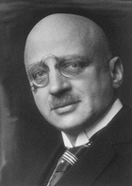
Chemical fertilizers provide an abundant source of nitrogen for plants. Up to the beginning of the 20th Century, nitrogen fertilizers were obtained by mining saltpetre (NaNO₃) from countries such as Chile, but supplies began to run out. In 1908 Fritz Haber discovered a chemical process to make ammonia gas (NH₃) from nitrogen and hydrogen that could be used to make artificial fertilizers. Carl Bosch commercialized the process in 1910. In 1918 Haber won the Nobel Prize in Chemistry for his discovery.

The process involves the reaction of hydrogen and nitrogen gas to
FRITZ HABER ¹
1868-1934
produce ammonia gas.
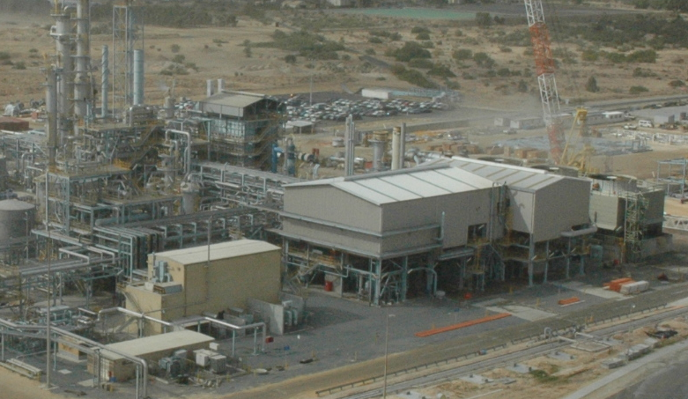

The clever technology actually involves producing the N₂ and H₂ in the right proportions for the reaction. This is called Synthesis Gas. In Kwinana Western Australia, the company Wesfarmers CSBP is a major manufacturer of NH₃ and uses this process.

Your mission is to research this process.
Points you need to consider:

- How is the Synthesis Gas produced? (NOTE: You do not need to memorise this process).
- Using chemical principles you have learned regarding reaction rates and equilibrium, explain how the yield of ammonia is optimized.
- What are the environmental considerations for this process?
- What are the major uses for ammonia and what difference has the Haber-Bosch process made to humanity since the start of the 20th century?

